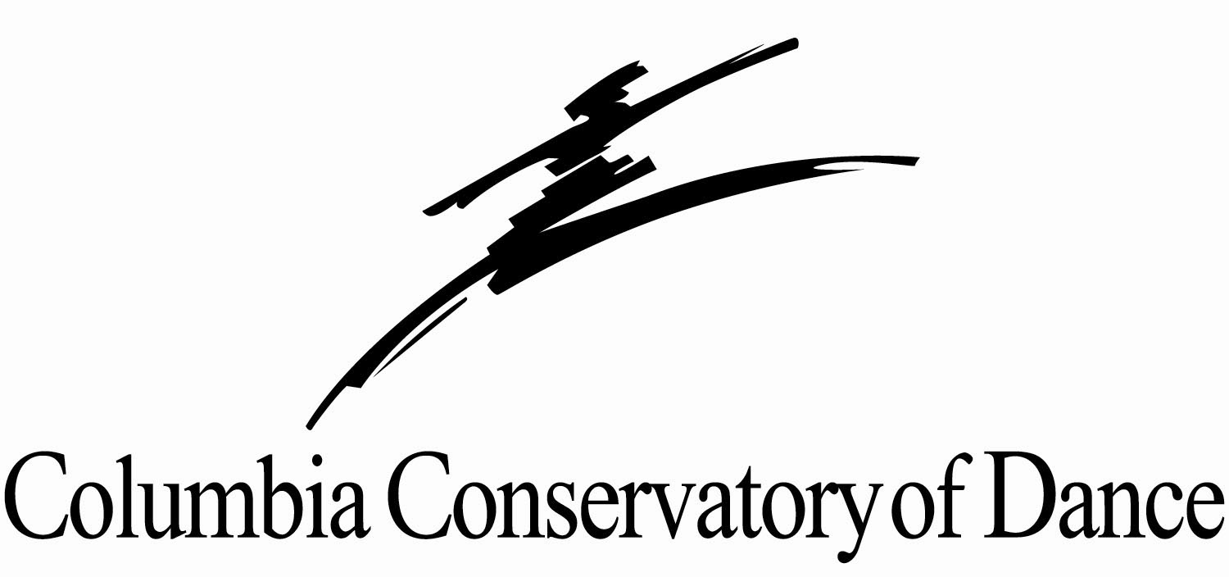

Mariclare Miranda & William Starrett
Co-Owners & Principal Instructors

Classes begin Monday, August 15, 2022

Downtown Columbia – 1545 Main Street

(803) 252-0555
columbiaconservatoryofdance.com
ccdance1988@gmail.com

Ages 3 to Adult

Creative Movement, Pre Ballet, PreTap, Ballet, Pointe, Jazz, Lyrical & Contemporary

Fees:
- $25.00 (non-refundable) per student due on or before first lesson with completed registration form
- Monthly tuition to be paid by ACH draft, Credit Card or check due on the 1st of every month. ACH draft will begin September 1, 2022
- Performance Fee $50
- Costume Fee $75 per costume ordered
- Unlimited Class Fee $475 monthly
- 5% discount for families with 3 or more registered dancers
- 50% discount for male dancers (private lesson excluded)
- $25 late fee charged on account balance after 10th of the month
- $35 fee for returned checks

School Tuition Fees
Monthly tuition per week | 30 min class | 45 min class | 60 min class | 90 min class
1 | $55 | $65 | $70 | $80
2 | $110 | $125 | $135 | $165
3 | $160 | $190 | $205 | $235
4 | $215 | $255 | $275 | $315
5 | $270 | $320 | $345 | $395

Private Lessons - Ms. Miranda or Mr. Starrett: $55.00 (30 minute Private)

CCD Staff Instructor: $50.00 (30 minute Private)
$35.00 (per dancer Semiprivate)
Payment for private lessons due at the time of lesson

Daytime Program – Supplemental ballet training for the Intermediate/Advanced dancer with studio directors’ acceptance. Classes held Monday, Wednesday & Friday 12:30p – 3:30p. Monthly tuition $325. Start date Monday, September 7, 2022

2022-2023 COLUMBIA CONSERVATORY OF DANCE SCHEDULE
Classes begin Monday, August 15, 2022

 | MONDAY | TUESDAY | WEDNESDAY | THURSDAY | FRIDAY
B  R  O  D  I  E | 12:30-3:30 Day Program MM  5:30-7:00 Ballet Jr/B MM  7:00-8:00 Contemporary GG | 4:30-5:30 Ballet Ball JH  5:30-7:00 Ballet Jr/B WS  7:00-8:30 CCBII | 12:30-3:30 Day Program MM  4:15-4:45 Pre Ballet 2 MM  4:45-5:30 Ballet D2 MM  5:30-7:00 Ballet Jr MM  7:00-7:30 WS Private  7:30-8:30 Jazz/Lyrical A/B JH | 4:30-5:30 Teen Ballet MM  5:30-7:00 Ballet Jr WS  7:00-8:30 CCBII | 12:30-3:30  Day Program MM  4:00-7:00  CODA MM
L  A  V  O  I  E | 3:15-3:45 Pre Tap CR  3:45-4:15 Creative Movement CR  4:15-5:00 Ballet D1 CR  5:00-5:45 Ballet D2 CR  5:45-6:30 Jazz/Lyrical D GG | 5:30-6:30 Ballet C3/C2 Tech MM  6:30-7:00 Ballet C3 Pt MM | 5:00-6:00 Ballet C3/C2 Tech WS  6:00-6:30 Ballet C3 Pt WS  6:30-7:00 WS private | 5:00-5:30 WS Private  5:30-7:00 Ballet B MM
S  P  O  H  R | 5:45 – CR Privates | 5:00-5:30 WS Private  5:30-6:30 Ballet C1 JH  6:30-7:00 Ballet C2 PP JH | 3:45-4:15 Pre Jazz JH  4:15-4:45 Pre Ballet1 JH  4:45-5:30 Ballet D1 JH  5:30-6:15 Jazz/Lyrical D JH  6:30-7:30 Jazz/Lyrical C2 JH | 3:45-4:45 JH Privates  4:45-5:45 Ballet C1/C2 JH  5:45-6:15 Ballet C2 PP JH  6:15-7:00 Jazz/Lyrical C1 JH
WS – William Starrett MM – Mariclare Miranda JH – Jordan Hawkins CR – Claire Rapp GG – Gabrielle Gardner

Attire For All Classes -
Bun is required for all ballet classes. At least a ponytail for all other classes. Hair is not to be in face or on shoulders. Proper hair is part of class attire and is strictly enforced. Student may be excused from class for not having proper hair and clothing. If assistance is needed, please let us know, and we will be happy to help. Just be sure to bring the supplies. Please put student’s name in all dancewear and dance shoes!
No leg warmers or jewelry worn in class. Keep all valuables at home.

Creative Movement- Black or Pink leotard, ballet pink tights, pink leather ballet shoe

Pre Ballet 1, 2- Black or Pink leotard, ballet pink tights, pink leather ballet shoe

Ballet D 1, 2 - Black leotard, ballet pink Capezio #18, tights, pink leather ballet shoe

Ballet C1 - Black leotard, ballet pink Capezio #18, tights, pink leather ballet shoe, pink pointe shoe with black waist alignment belt

Ballet C2 - Black leotard, ballet pink Capezio #18, tights, pink leather ballet shoe, pink pointe shoe with light pink waist alignment belt

Ballet C3 - Black leotard, ballet pink Capezio #18, tights, pink leather ballet shoe, pink pointe shoe with red waist alignment belt

Ballet B1- Black leotard, ballet pink Capezio #18, tights, pink leather ballet shoe, pink pointe shoe with lilac waist alignment belt

Ballet B2 – Black leotard, ballet pink Capezio #18, tights, pink leather ballet shoe, pink pointe shoe with turquoise waist alignment belt

Junior Ballet - Black leotard, ballet pink Capezio #18, tights, pink leather ballet shoe, pink pointe shoe with white waist alignment belt

Male (all levels of ballet): White t-shirt, black tights with white socks, white leather ballet shoe with white waist alignment belt

Pre Tap 1, 2- Black leotard, ballet pink Capezio #18 or tan tights, black patent tie tap shoe

Male - Black jazz / sweat pant, solid color t-shirt, tap shoe Capezio CG17

Jazz/Lyrical (all levels): Colored leotard and dance/biker short are acceptable, tan Capezio tights #1916, tan Bloch shoe #S0401

Male (all levels of jazz): Black jazz / sweat pant, solid color t-shirt, jazz shoe tan Bloch 401

Contemporary - Colored leotard and/or dance/biker short are acceptable, teacher will advise on shoe

Office hours Monday – Thursday, 3:00pm – 7:00pm, closed Friday – Sunday. You may call 803-252-0555, and messages will be returned.
- Website address – www.columbiaconservatoryofdance.com
- Email address – columbiaconservatory@sc.rr.com

Registration
- A completed registration form on every student is needed on file. This form, along with the registration fee, is due on or before the first lesson.
- The Conservatory charges a yearly, non-refundable $25 registration fee.
- You will be charged for the classes you have registered for, even if you do not attend, until we receive written notice of withdrawal. Written notice must be made in advance of any changes.

Fee and Payments
- Tuition paid with choice of ACH bank draft, a provided credit card or check, due the 1st of the month.
- All checks to be made out to Columbia Conservatory of Dance (CCD) and include the student’s name and what the payment is for in the memo section of the check.
- No refunds are given for registration, tuition or commencement fees. After the 10th, the account will be considered delinquent and a late fee of $35 will be charged to your account. Payments will be credited to the oldest charges first if there is a balance due.
- Class fees are calculated on the cost for the entire school year, August 2022 – May 2023, paid in monthly installments.
- Tuition payments are required regardless of student’s attendance.

Class Attendance
- Children should arrive 15 minutes before the scheduled class and picked up promptly at the end of your dancers’ last class.
- Tardiness to class not only disrupts the class but also prevents the student from getting full benefit and the discipline expected. If the student is to be late to class, please contact the main office to notify us so we may notify the instructor.
- If a student is to miss class, please contact the main office and to inquire about a make-up class within the two-week allowance. Refund is not given for missed classes.
- If a child is to discontinue a class, we would greatly appreciate notification as to reason.
- The Conservatory rewards students who attend every scheduled class. A medal for Perfect Attendance is presented during our Commencement Exercises. Make-up classes do not apply, and eligibility begins the week of August 15, 2022.

Commencement Exercises
- Each year the Conservatory concludes the dance school year with a performance, otherwise known as recitals.
- In September, a performance fee of $50 is due with your monthly tuition. This fee helps to pay for the facility and various other things needed to highlight the dancers’ progress over the past year. You will be billed separately for costume, in some cases, costumes, in October.

Parent Correspondence
- Parents may enter the dance classroom by invitation only. Classes run back-to-back, so it is very difficult for the instructor to have time to talk with you during class time. Please contact the main office or the individual instructor to set up an appointment if you need to discuss any concerns.
- Our front lobby is open when waiting on your student.
- Please communicate with instructors any health issues concerning your child.
- The Conservatory sends home notes occasionally and always posts information in the studio lobbies and on social media. You’re welcome to come in and check on a regular basis.

School Closings
In case of inclement weather or other uncontrollable events, the studio will post on our social media outlets as well as sending out an email. There is no refund for this.

Lost & Found
All items left at the studio will be placed in the lost & found bins and kept for 1 month. We donate to charities.

Covid Protocol
The safety of our students, their families, and our employees is our top priority. We continue to closely monitor the Corona virus (COVID-19) and are acting based on guidance from public health experts and the guidelines provided by SCDHEC and the CDC as well as local, State and Federal authorities.

We ask that anyone attending classes at the Conservatory, monitor their health and that of their family members, and we encourage you to take appropriate precautions for preventing illness. We ask that if you or your child are feeling unwell, please remain at home!

Holidays
2022
First Day of Classes - August 15
Labor Day – September 5
Thanksgiving Break – Wednesday, November 23 – Friday, November 25, resuming Monday, November 28
Winter Break - Thursday, December 22 – Tuesday, January 3, 2023
2023
Classes resume from Winter Break - Wednesday, January 4, 2023
Spring Break – Monday, April 10 – Friday, April 14, resuming Monday, April 17
Commencement Exercises (recitals) - Friday, May 19 & Saturday, May 20

